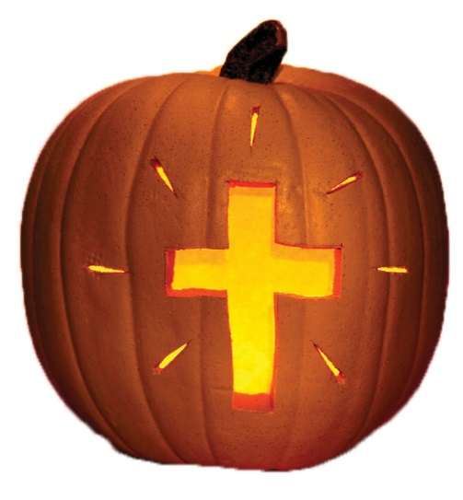
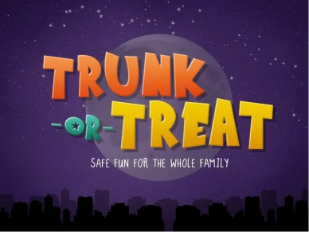

Come & join us for a community wide family fun event!

Tuesday, October 31, 2017
5:30 PM to 6:30 PM

Trinity Lutheran Church Parking Lot
634 Alden Drive (Just north of Pizza Hut/Spookfest)

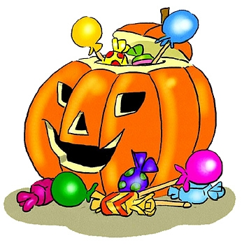
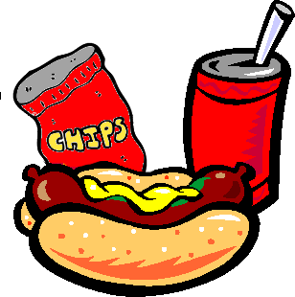
Hot dogs, chips and a drink will be provided in addition to free candy!

