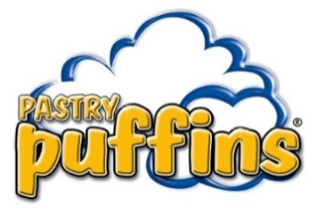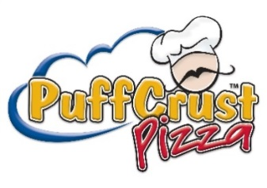
Dear Participants and Parents,

Trinity Evangelical Lutheran Church is very excited to offer Pastry Puffins®, PuffCrust Pizza™, and ButterHearts™ as our fundraising program.

Pastry Puffins® are a delicious, Classic Puff Pastry. Each Pastry Puffin® has hundreds of alternating thin layers of pastry to make them a melt-in-your-mouth flaky Treat! Pastry Puffins® are a Freezer-To-Oven product, no thawing required. The Pastry Puffins® are available in Five Different Delicious flavors.

PuffCrust Pizza™ is a one-of-a-kind Pizza experience. The Puff Pastry Crust is infused with mozzarella cheese and pizza seasoning. Delicious meats and cheeses are inside making this a Pizza-Lovers delight. One Box of PuffCrust Pizza™ weighs 18.5 oz. There are 2 individual PuffCrust Pizzas™ inside each Box, which makes 12 Puffin sized servings per box. PuffCrust Pizza™ is available in TWO delicious flavors.

ButterHearts™ are a Flaky, multi- layered puff pastry shaped like a heart that is sprinkled with sugar and then baked until the sugar is caramelized. They are soft and chewy and melt in your mouth delicious! One Package of ButterHearts™ weighs 24oz. There are 12 ButterHearts™ per package. ButterHearts™ are available in Two delicious flavors

The proceeds from the sale will go towards 2019 LCMS National Youth Gathering. The goal for the sale is to raise $. To reach our goal, each participant should sell items.

If you need additional information about the products we are selling, visit the product website at www.pastrypuffins.com where you will find more descriptive product details and information about your fundraising products.

The dates of our sale are listed below. Please mark the delivery date on your calendar and make sure you remember to pick up your order on delivery day.

Start Date: Nov 18, 2018
End Date: Dec 8, 2018
Delivery Date: TBD but most-likely Dec 16, 2018

Feel free to contact me with any questions and thanks in advance for helping make this sale a huge success.

Thank you,
Sarah Bogdanoff
Cell Phone: (619)993-1120
Email: sarah.e.bogdanoff@gmail.com

NOTE! If our group gets 100 more boxes than last year (we got 34), that's an extra $40 bucks! If we sell 250 or more boxes, we automatically get an extra $250 or more bucks! There are prizes for individuals that sell 30, 50, 100, 150, and 200 boxes, too (that last one is an extra $160 bucks)!
With the Christmas Bazaar and a little bit of work, let's see if we can hit 134 ($710), maybe even 250 ($1,315)!
There are eleven Youth - if each Youth sells 13 (or maybe even 23) boxes, we can hit one of those goals and go a long way toward the NYG fundraising goal of $6,000 =]

